30.36: Equation (30.20) is 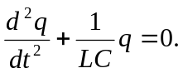 We will solve the equation using:
